1. **Purpose**

This SOP describes the process of thawing of all Comirnaty COVID-19 vaccines stored frozen at

-90°C to -60°C (ultra-low temperature) including:

* safe handling processes for vaccines stored at ultra-low temperatures (ULT)
* transferring vaccines into a refrigerator to thaw
* assigning a post-thaw expiry date

1. **Scope**

This SOP is applicable to the thawing in a refrigerator of all Comirnaty COVID-19 vaccines stored on site frozen at -90°C to -60°C in ULT freezers.

For receipt and immediate thawing of ULT frozen Comirnaty vaccines refer to SOP HCV 3, for receipt and ULT storage of Comirnaty vaccines refer to SOP HCV 4.

For receipt and storage of all COVID-19 vaccines received at 2°C to 8°C refer to SOP HCV 1 and for receipt and storage of frozen Spikevax vaccines, refer to SOP HCV 2.

1. **Responsibility**

Only staff suitably trained and competent in working with ULT freezers and the allocation of post-thaw expiry dates may perform this activity.

In addition to the PPE provided, staff must wear clothing that covers their legs and arms, and shoes must be completely enclosed.

1. **Health and Safety rules for working with ultra-low temperature freezers**

* The inner surfaces of ultra-low temperature freezers may cause cold burns
* In addition to the PPE provided (specify locally e.g. mid-length gauntlets and goggles or face shield and apron), staff must wear clothing that covers their legs and arms, and shoes must be completely enclosed.
* First aid for ultra-low temperature burns is the same as for heat burns: treat with tepid running water and seek medical attention.

1. **Procedure**
   1. Before beginning, check how many cartons need to be moved from the freezer to the fridge for defrosting
   2. Collect:

* ultra-low temperature handling PPE (specify locally e.g. mid-length gauntlets and goggles or face shield and apron)
* disposable gloves to wear under the gauntlets (if required by local infection prevention and control procedures)
* a narrow-tipped permanent marker
* a trolley if not working immediately beside the fridge.

* 1. Check the temperature display on the fridge to ensure it is between 2 and 8OC, the control panel on the freezer to ensure that it is within the range -90°C to -60°C, and that no alarms are displayed. If either is out of range or is showing an alarm, do not proceed and report to [insert details here].
  2. Unlock freezer.
  3. Put on the PPE.
  4. Open the outer and inner freezer door and remove the carton(s) from the freezer, keeping the freezer door open for as short a time as possible, and place them onto the trolley or a bench immediately adjacent to the fridge. If there is any distance to travel between the fridge and the freezer use the trolley instead of carrying the cartons.
  5. Close the inner and outer freezer door and lock it again (remove gauntlets to do this if necessary).
  6. Amend the expiry date:
* calculate the post-thaw expiry date. This is 31 days from removal from the freezer, provided this is not past the original expiry date.
* write the post thaw expiry date on the carton in the space provided using a narrow-tipped permanent marker (see Appendix 1).
* cross out the original expiry date.
* obtain a check that the calculated post-thaw expiry date is correct.

N.B. the expiry is calculated to the nearest day. There is no need to record expiry time. The expiry will be at midnight at the end of the calculated day of expiry.

* 1. Transfer the cartons into the fridge to thaw. This may take up to 3 hours.
  2. Again, check the temperature display on the fridge to ensure it is between 2 and 8OC, the control panel on the freezer to ensure that it is within the range -90°C to -60°C, and that no alarms are displayed. If either is out of range or is showing an alarm, do not proceed and report to [insert details here].
  3. Remove PPE and store in a designated clean, dry location. If the goggles or visor may be worn by someone else, wash in soapy water or wipe them down with a bactericidal wipe and leave to dry.
  4. Remove and discard the disposable gloves according to local waste disposal practices and wash your hands.

1. **Document history**

|  |  |  |  |
| --- | --- | --- | --- |
| **Date** | **Version** | **Section** | **Details** |
| 18/08/2022 | 1.0 | All | This is the first version published. Supersedes VH6. |

1. **Associated documents**

SOP HCV 3: Receipt of ULT frozen Comirnaty, thawing, and assigning a post-thaw expiry date

SOP HCV 4: Receipt of ULT frozen Comirnaty and storage in ULT freezer

1. **References**

<https://www.sps.nhs.uk/articles/handling-dry-ice-and-vapour-phase-nitrogen-shippers-advice-for-hospital-pharmacies/>

**Appendix 1**

Example of how to amend expiry on packaging when thawing Comirnaty COVID-19 vaccines.

Comirnaty 30 Concentrate:

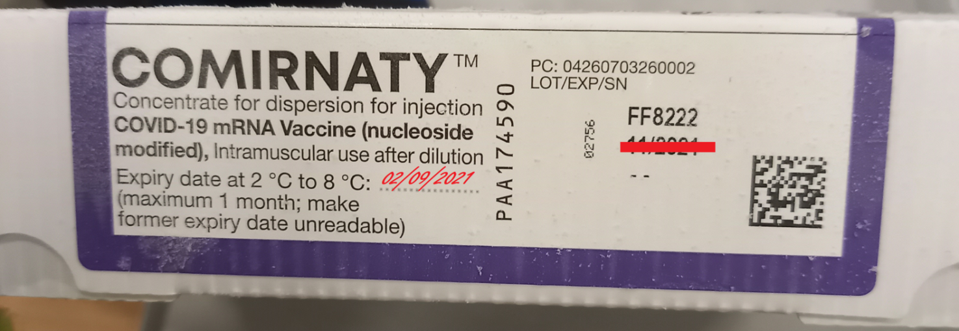

Comirnaty 10 Concentrate:

