1. **Purpose**

This SOP describes the process of receipt and thawing of all Comirnaty COVID-19 vaccines received frozen at -90°C to -60°C (ultra-low temperature) including:

* safe handling processes for vaccines supplied at ultra-low temperatures (ULT)
* transferring vaccines into a refrigerator to thaw
* assigning a post-thaw expiry date
* recording data attributes needed to provide data for the national vaccination programme.

1. **Scope**

This SOP is applicable to the receipt and **immediate thawing** in a refrigerator of all Comirnaty vaccines received frozen at -90°C to -60°C.

For receipt and ULT storage of Comirnaty vaccines refer to SOP HCV 4, and for thawing Comirnaty vaccines removed from a local ULT freezer refer to SOP HCV 5.

For receipt and storage of all COVID-19 vaccines received at 2°C to 8°C refer to SOP HCV 1 and for receipt and storage of frozen Spikevax vaccines, refer to SOP HCV 2.

1. **Responsibility**

Only staff suitably trained and competent in handling dry ice (carbon dioxide) and the allocation of post-thaw expiry dates may perform this activity.

In addition to the PPE provided, staff must wear clothing that covers their legs and arms, and shoes must be completely enclosed.

This process should be performed in pairs. One person should lead on performing the stock checking aspects of the procedure and the other should lead on safe handling of the vaccine and the ULT shipper. Either person may lead on allocation of the post-thaw expiry date. Both people are responsible for ensuring there is no delay between removal of cartons from the shipper and placing them in the ULT freezer.

1. **Health and Safety rules for handling dry ice and working with ultra-low temperature freezers**

* Dry ice and ultra-low temperature freezers may cause cold burns, and carbon dioxide gas may cause asphyxiation if it is not allowed to escape into the atmosphere
* Always work in pairs when unpacking deliveries from dry ice.
* In addition to the PPE provided (specify locally e.g. mid-length gauntlets and goggles or face shield and apron), staff must wear clothing that covers their legs and arms, and shoes must be completely enclosed.
* Always ensure good ventilation:
  + Never move shippers containing dry ice in a lift
  + Never place shippers containing dry ice in a cold store or fridge, or other unventilated areas
* Always leave the dry ice in the shipper
* First aid for dry ice burns is the same as for heat burns: treat with tepid running water and seek medical attention.

1. **Procedure**
   1. **Accepting the delivery**
      1. Before receiving a vaccine delivery ensure dry-ice handling PPE [specify locally e.g. gloves/gauntlets and goggles or visor] are readily to hand.
      2. Check:
   * the number of shippers matches the number listed on the delivery note, carrier’s receipt or proof-of-delivery device
   * all shippers are in good condition and no damage is evident.
   * all shippers are addressed correctly
   * the shippers have not expired
     1. If any part of the delivery is damaged, already opened, missing or otherwise not as expected report without delay to [insert senior staff job title].

If the delivery appears to be in order, accept the shipment according to the established acceptance-of-delivery process.

* 1. **Preparing to unpack the delivery**
     1. Work in a designated well-ventilated area, as close as possible to the fridge.
     2. Collect:
* ultra-low temperature handling PPE (specify locally e.g. mid-length gauntlets and goggles or face shield and apron)
* disposable gloves to wear under the gauntlets (if required by local infection prevention and control procedures)
* a narrow-tipped permanent marker
* a trolley if not working immediately beside the fridge.
  + 1. Check the refrigerator is within the range 2°C to 8°C and that no alarms are displayed. If out of range or is showing an alarm, do not proceed and report to [insert details here].
    2. Check that the shipper is within its expiry date.
    3. Put on the PPE.
  1. **Unpacking the delivery and amending the expiry date**
     1. Remove the cartons from the shipper and place them onto the trolley or a bench immediately adjacent to the fridge. If there is any distance to travel between the shipper and the freezer use a trolley instead of carrying the cartons.
     2. Replace the inner lid on the shipper to contain the dry ice.

* + 1. Check:
       - the tamper evident seals are intact
       - there is no evidence of any damage
       - the identity, batch number, expiry date and quantities against the delivery note.

and endorse the delivery note to confirm.

* + 1. If there is any damage or discrepancy,
       - quarantine the stock in the fridge, clearly identifying them e.g. in a separate bag
       - report without delay to [insert senior staff job title].

N.B. If any vials are broken, wait for them to warm above freezing temperatures and then deal with the spillage following SOP HCV 7. No special spillage procedures are required for thawed Comirnaty COVID-19 vaccines.

* + 1. Amend the expiry date:
* calculate the post-thaw expiry date. This is 31 days from removal from the shipper, provided this is not past the original expiry date.
* write the post thaw expiry date on the carton in the space provided using a narrow-tipped permanent marker (see Appendix 1).
* cross out the original expiry date.
* ask the other person to check that the calculated post-thaw expiry date is correct.

N.B. the expiry is calculated to the nearest day. There is no need to record expiry time. The expiry will be at midnight at the end of the calculated day of expiry.

* + 1. Transfer the cartons into the fridge to thaw. This may take up to 3 hours.
  1. **Completion of housekeeping tasks:**
     1. Close the shipper box and use the trolley to remove it to [insert details of secure well- ventilated location]. Keep on all PPE, except gauntlets if it is essential to remove them e.g. to open a locked door.
     2. Put gauntlets back on again (if removed) and position the shipper box with lid ajar.
     3. Secure the location and leave to allow the carbon dioxide to turn to gas (sublime) for at least 24 hours.
     4. Remove PPE and store in a designated clean, dry location. If the goggles or visor may be worn by someone else, wash in soapy water or wipe them down with a bactericidal wipe and leave to dry.
     5. Check the refrigerator is still within the range 2°C to 8°C and that no alarms are displayed. If out of range or is showing an alarm, do not proceed and report to [insert details here].
     6. Remove and discard the disposable gloves (if worn) according to local waste disposal practices and wash your hands.
     7. Once the carbon dioxide has completely sublimed, discard the shippers with general and cardboard waste following normal Trust procedures.
  2. **Log receipts on the stock control system**
     1. For each purchase order, receive the goods on to the stock control system (Foundry and pharmacy stock management system).
     2. Forward completed delivery documentation to [insert job title].
     3. Receipt of vaccine on to the pharmacy stock management system must capture the following product details:
  + Date and time received into system
  + Supplier
  + Purchase order number
  + dm+d medicine name (AMP/P) This must be the ‘branded’ level description
  + dm+d ID code
  + Pack size and number of vials received
  + Batch number (This cannot be scanned and **must** be checked by a second person to ensure the correct information is recorded)
  + Expiry of vials

1. **Document history**

|  |  |  |  |
| --- | --- | --- | --- |
| **Date** | **Version** | **Section** | **Details** |
| 18/08/2022 | 1.0 | All | This is the first version published. Supersedes VH4 |

1. **Associated documents**

SOP HCV 1: Receipt and storage of COVID-19 Vaccines at 2-8°C

SOP HCV 3: Receipt of ULT frozen Comirnaty, thawing, and assigning a post-thaw expiry date

SOP HCV 4: Receipt of ULT frozen Comirnaty and storage in ULT freezer

SOP HCV 5: Removing ULT frozen Comirnaty from ULT freezer, thawing, and assigning post-thaw expiry date

1. **References**

<https://www.sps.nhs.uk/articles/handling-dry-ice-and-vapour-phase-nitrogen-shippers-advice-for-hospital-pharmacies/>

**Appendix 1**

Example of how to amend expiry on packaging when thawing Comirnaty COVID-19 vaccines.

Comirnaty 30 Concentrate:

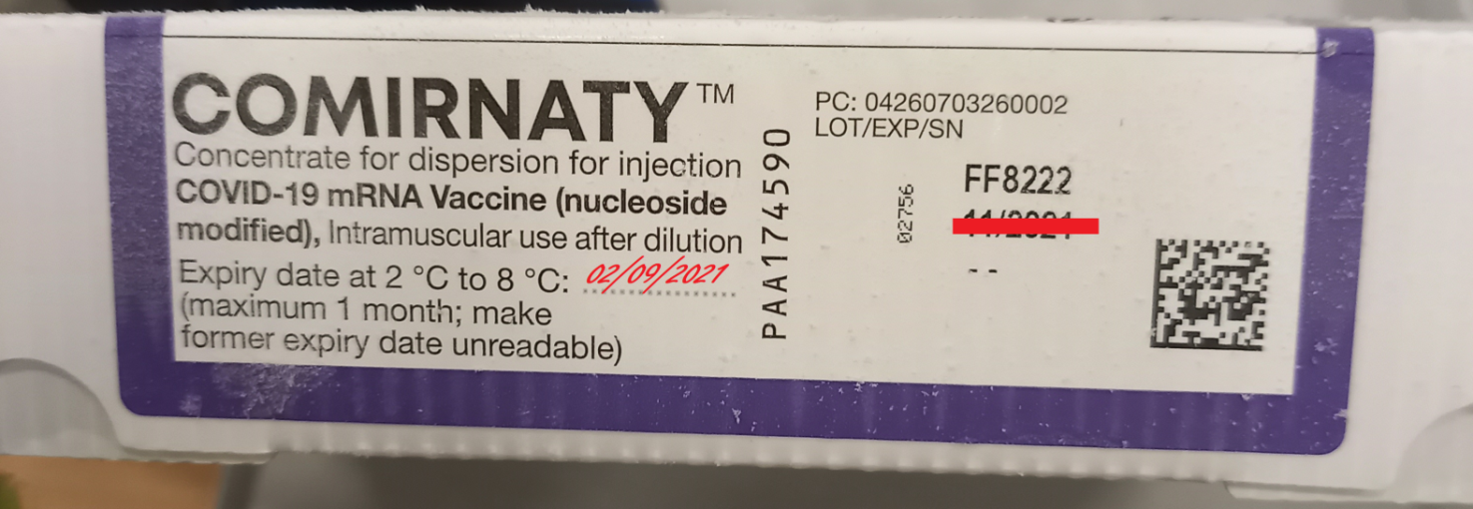

Comirnaty 10 Concentrate:

