A Toolkit for Managing Stock at Trust Level
Purpose of This Paper
This paper is designed to provide the reader with the basic generic principles for managing stock within their pharmacy department. If these simple principles are adhered to, the stock held should be relevant and the wastage minimal. The paper applies the generic principles to each of the commonly used pharmacy computer systems allowing the reader to use their stock control system to its potential.

Introduction
There are several reasons for holding stock (to provide a service level, as a hedge against fluctuating demand, for convenience, as a buffer against uncertainty or for quantity discounts). However holding stock incurs the following costs.
- Space (rent/ heat / light etc.)
- Staff time
- Lost interest on money tied up in stock
- Lost opportunity costs (you could have done something else with the money)
- Deterioration of stock
- Obsolescence of stock
- Insurance costs
- Losses (theft)
- Inventory control costs
These costs are estimated to be 25% of the book value of the stock per year (1). Stockholding is always a compromise of stock holding costs vs. service level to your customers (how many to follows you generate to wards and departments). Note that stock outs cost in time spent chasing orders, carriage charges etc. It also damages your reputation with customers and peers.

To manage stock effectively you must address three key questions.
A) How much stock to hold
B) How much stock to order
C) How often to order
The purpose of this paper is to provide you with the answers to these questions AND to show how this can be done with your pharmacy system.

A) How Much Stock to Hold
- Calculation of Stock Holding
It is important to know how much stock you hold at any time. Most systems allow this figure to be generated.
- Calculation of Annual Spend
Annual spend is also vital. This figure can be obtained from your pharmacy system
- Calculation of Stock Turnover
  - This simple calculation tells you the theoretical number of times your stock turns over per year. Calculate by

Annual Spend Figure
      - Stock Turns = Average Stock Value

  - A typical value for stock turns is 12-16.
  - A figure less than this means you may have too much stock.
  - A figure over this means you may be generating too many orders. Check your service levels, are they adequate?
  - Stock turns are often converted into numbers of weeks of stock. This is done by dividing 52 by the stock turn figure. Remember this is an “average” figure. This figure would typically be from 3 to 6 weeks. Different types (categories) of stock will move at different rates.

- Adjusting Stock Holding
- Stock holding can be adjusted in several ways.
  - By adjusting the number of weeks stock you ask the pharmacy system to hold
  - By adjusting individual minimums and maximums and fixing them so they do not move. You may need to fix minimums on stock when you need to hold a certain amount (for a course of treatment) but the stock is only used occasionally.
  - You may need to fix a maximum if you have a limited amount of storage space (fridge).

- Categorisation of Stock
Not all stock is the same. Some moves faster than others, some is more critical to the patient (a life saving antibiotic vs. a vitamin tablet), some is more expensive than others. ABC analysis is a standard way of analysing stock. See Diagram 1.
Different types of stock should be managed differently. Categorise your stock into:-
  - Fast Movers: Fix maximums if you have space considerations (e.g. fridge item).
  - Slow Movers: Do you need to hold this at all, could you source it from wholesalers even at increased cost? Fix minimums where a set amount is required to be kept (e.g. antibiotic or antidote).
  - High Cost Items: Manage this stock very carefully. Ensure stock is rotated and does not expire. Ensure stock levels are the minimum required. Sourcing from a wholesaler will move the cost of storage from you to them.
  - Critical Items: (Vital see Appendix 1) Make sure you have minimums set correctly and fixed if needs be. Ensure source is reliable and consider wholesaler for fast response. Do not totally rely on them however.
  - Bulky Items: Consider fixing maximums to limit storage. Again ideally obtained little and often (wholesaler).
  - Special Storage: As above.
You may wish to categorise some suppliers (with poor supply performance) and increase the stock holding for the items they provide (or even better hold more safety stock and hence order earlier).

- Stock Holding Locations
Stock is normally held in two or more locations within a department. The generic rules for stock holding are the same for a satellite unit requisitioning from a pharmacy store as for a store ordering from a supplier. (Hopefully the lea time will be less!) The pharmacy system may well have different set up options and rules for stock holding and requisitioning compared to ordering from outside suppliers.
- Where to Hold the Stock
The more locations you hold stock in (store, dispensary, CIVAS unit, satellite unit), the more stock you will have in total. It makes sense to hold the stock where it is needed so much as is possible. For example if a specialist item is only used at one site (say a cytotoxic unit) then consider holding all stock there and having it delivered direct. This may not be possible for space or logistic reasons, but will minimise the stock you hold. Conversely if stock needs to be held in a wide number of locations, then the least stock is held when the minimum stock is held at the satellite locations and the bulk of stock is held centrally (either in one satellite or more usually the store).

B) How Much Stock to Order
An “Economic Order Quantity” (EOQ) can be calculated. This balances the costs of raising an order (time etc) against the costs of holding the stock (as above). Systems will calculate order size with an algorithm. This will usually use the following factors

- Lead time from supplier
- Prediction of Usage
- Stock already on order
- The amount of weeks stockholding set on the system (the target stockholding)

These factors can be adjusted to change the stock ordered. It is important to know how your system calculates the order quantity.

C) How Often to Order
This is done either by periodic review (the stock is topped up to a maximum at a set time interval), or more usually by a fixed order point system (stock is ordered once it passes through a minimum stack holding). Some systems work on a mixture in that once an order is raised by an item passing through the minimum; other items from that supplier are “topped up” by a review mechanism.

Checking Stock Levels
Stock levels are never accurate and need to be checked regularly. Computer systems have ways of accomplishing this.

Kevan Wind 1.4.2015

References
Impact of E-Business on Supply Chain Management: Kenneth Lysson: CIPS Guide ISBN 1-84152-091-8
Diagram 1
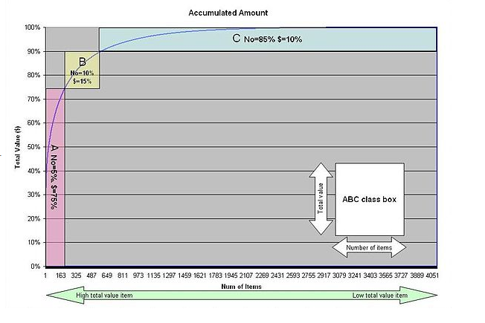Stock can be categorised into A B or C by percentage of total value (see below). 10% of the number of lines will typically be worth 60% of the total value. The same can be done substituting criticality for value. ABC is often replaced with VEN (Vital Essential and Non Essential in this case.

